TOSCA OVERVIEW
– 1000 words
Reprinted from “Coda Magazine” (Fall 2017) of the Boston Lyric Opera
Laura Stanfield Prichard

Composer Giacomo Puccini (1858-1924) based his Tosca on the 1889 play La Tosca by Victorien Sardou. He had seen a performance of it while working on Manon Lescaut (even Verdi was interested in it!), and was taken with the thriller. He began work in earnest in 1896, after asking his publisher Giulio Ricordi wrangle the rights for Sardou’s play from Alberto Franchetti, another composer who worked with librettist Luigi Illica. A tempestuous tale of seduction, cruelty, and deception, this opera presents a fierce battle of wills set against the backdrop of the Napoleonic Wars. Conductor James Levine has described it as “Puccini’s glorious musical inspiration [combined] with the melodramatic vitality of one of the great Hitchcock films.”

The creative team that Puccini and his publisher put together was superb: Luigi Illica created the scenario and Giuseppe Giacosa created the poetic language of the libretto. This trio had worked together on La Bohème, and in 1904, would later produce Madama Butterfly. Puccini was attracted to the ironic contrasts in the play: Cavaradossi is tortured, but doesn’t confess (Tosca does); “sweet and innocent hands” kill Scarpia; Angelotti survives by disguising himself; and some of the deaths we witness are meant to be faked. Over the course of three acts, the creators combined heart-pounding tension and suspense with portraits of devotion and courage. We are presented with three questions: how far would you go to protect a friend? What you do to save someone you love? How would you choose when law and citizen responsibility collide?

Puccini visited Sardou twice in Paris (in April 1898 and January 1899) to discuss the adaptation and demanded two big changes to Act III. Sardou gave in on the first point and allowed Puccini to replace Cavaradossi’s (original) patriotic hymn with a love song. He did not acquiesce on the second matter: he wanted an abrupt, thundering finale, while Puccini preferred a more extended musical setting of Tosca’s death (think Mimi). The completed libretto takes a realistic approach to the passage of time and leans toward the verismo style: it includes scenes of physical and psychological torture, and most of the conflicts are between individuals (singing duets), rather than monumental forces.

In Bohème the villain was fate (Mimi’s illness and death), and the characters progressed inexorably through their bohemian lives (devoted to art and love) toward the tragic conclusion. In Tosca, both villains and heros struggle physically and mentally on stage, and you may expect a coup de théâtre at any moment. Puccini loved the operas of Richard Wagner, and combined his own style, shifting quickly between emotions and musical keys, with his own Leitmotifs for Baron Scarpia and the hidden well in Cavaradossi’s garden (a place of refuge):
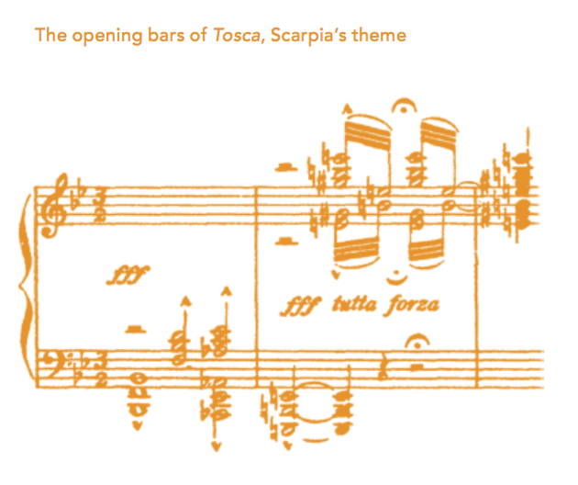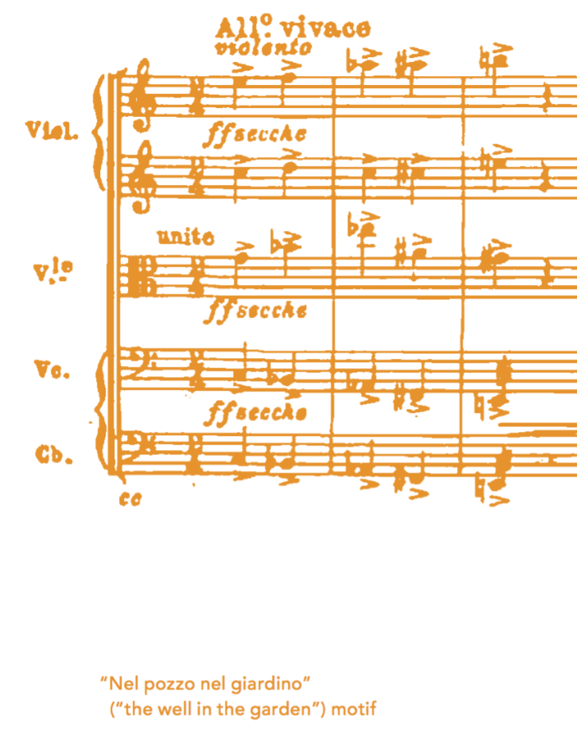
Puccini grew up in Lucca, north of Rome, but wanted Tosca to sound as Roman as possible. He researched not only when church bells were likely to have rung, but also how the exact bells of all the churches surrounding the Castel Sant-Angelo sounded. We hear them in Act I to announce the Angelus, they continue under prayerful singing, and they even provide counterpoint to Scarpia’s main musical theme. In Act II, Puccini’s includes a distant drum roll, reminding us of the French invasion of Rome and threatening Cavaradossi’s execution. Act III begins with the sounds of distant bells from the countryside, eventually drowned out by Roman city bells signaling the beginning of day in the city.

Tosca was first performed on January 14, 1900 at the Teatro Constanzi in Rome.
Recent productions include outdoor performances at Caracalla (the archaeological site of the Roman baths), director Luc Bondy’s co-production by the Metropolitan Opera (NYC), Teatro alla Scala (Milan), and Bayerische Staatsoper (Munich), and most directors prefer to recreate some elements from the original Roman locations Puccini scouted while composing.

The title role is a celebrated opera singer, and Floria Tosca must be considered a height of any soprano’s career. Although female sopranos were banned in Rome around 1800, women did perform during Carnival and private theatres. Tosca may pray in church, but not sing there! Leading Tosca include the contemporary soprano Karita Mattila (Finland) and historical divas Maria Callas, Maria Caniglia, and Maria Jeritza. The idealistic artist Mario Cavaradossi has featured tenors such as Brian Jagde, Jonas Kaufman, and Luciano Pavarotti. The corrupt police chief and church official Baron Scarpia (baritone) dominates the action of the first two acts. Leading singers of this role include George Gagnidze (featured on the recent Met broadcasts), Thomas Hampson, Ingvar Wixell, and Ruggero Raimondi. Cesare Angelotti, the political prisoner who has escaped from the Bonapartiste government appears in the first two acts, and notable performers of this role include basses Jamie Offenbach and Antonio Zerbini. Tito Gobbi played opposite Maria Callas in Tosca: during one performance, she came too near the candles burning on Scarpia’s desk in Act II and ignited her wig. Gobbi immediately jumped on Tosca, embraced her, and extinguished the flames. Tosca rejected him with disgust, but then whispered him a “Thank you, Tito,” just before stabbing him. Also memorable is Placido Domingo’s headlong fall while rushing down from the scaffolding during Act I in live television in Rome: he crashed into the fence of the real Cappella Attavanti, giving a definite hint of realism to the broadcast. In 1995, tenor Fabio Armiliato was actually shot in Act III after the pistol was overloaded with powder. Five days later, he returned to perform (on crutches), and fell during his Act II entrance, breaking his other leg. Apocryphal stories include a Tosca bouncing back up in the air after her Act III leap, and the soldiers following her off the parapet (after being told to “exit with the principals”).

Musical highlights
The two biggest hit arias from Tosca are easy to recognize, as Puccini brings his swirling action to a halt for them: in Act II, as Tosca is being blackmailed by Scarpia, she sings “Vissi d’arte,” [I’ve lived for art] saying that she's always lived her life for art, and for love, and this is where it's gotten her. The tenor's big moment comes in Act III. As he’s awaiting execution, Cavaradossi sings “E lucevan le stelle” [How the stars shimmer], looking back on his life, his love for Tosca, and how it has all come to nothing. He’ll die, he says, in desperation.

Act I, combining operatic and sacred musical forms, also showcases Cavaradossi. “Recondita armonia” compares the beauty of two very different women, introducing him as someone with an artist’s eye for detail and nuance. As the drama builds, Scarpia sings “Tre sbirri... Una carozza...,” describing his pursuit of a traitor during the singing of the Roman Te Deum canticle, and interrupted by Roman cannons announcing Napoleon’s defeat at Marengo. But was he really defeated? Scarpia also dominates Act II with his scene-chewing “Ha più forte sapore,” anticipating the submission of Tosca to his will.

